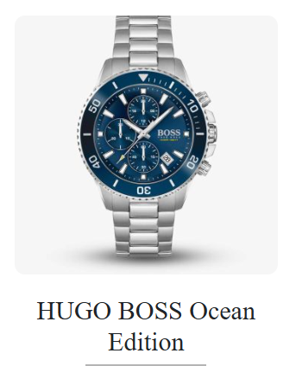

**🕰️ Product Name:** HUGO BOSS Ocean Edition Men's Watch (Model 1513707)

**📄 Description:**  
A sophisticated and sporty timepiece from the HUGO BOSS Ocean Edition series, featuring a sleek silver stainless steel bracelet and a striking blue dial. Designed for versatility, it's suitable for both casual and formal occasions.

**⚙️ Specifications:**

* **Movement:** Quartz
* **Case Size:** 44 mm
* **Case Thickness:** 11 mm
* **Case Material:** Stainless Steel
* **Dial Color:** Blue
* **Crystal:** Mineral Glass
* **Strap Material:** Stainless Steel
* **Strap Color:** Silver
* **Strap Width:** 22 mm
* **Clasp Type:** Push-button deployment clasp
* **Water Resistance:** 50 meters (5 ATM)
* **Functions:** Date display
* **Weight:** Approximately 142 grams
* **Warranty:** 1-year warranty for fashion brands (as per retailer)

**💰 Price:**

* Rs. 30,500